**Assisted Practice: 3.12 Delete an S3 Bucket**

This section will guide you to:

* Delete an S3 bucket

This lab has three subsections, namely:

3.12.1 Selecting the S3 bucket you want to delete

3.12.2 Deleting the bucket

3.12.3 Pushing the files to GitHub repositories

**Step 3.12.1:** Selecting the S3 bucket you want to delete

* Choose the bucket

**Step 3.12.2:** Deleting the bucket

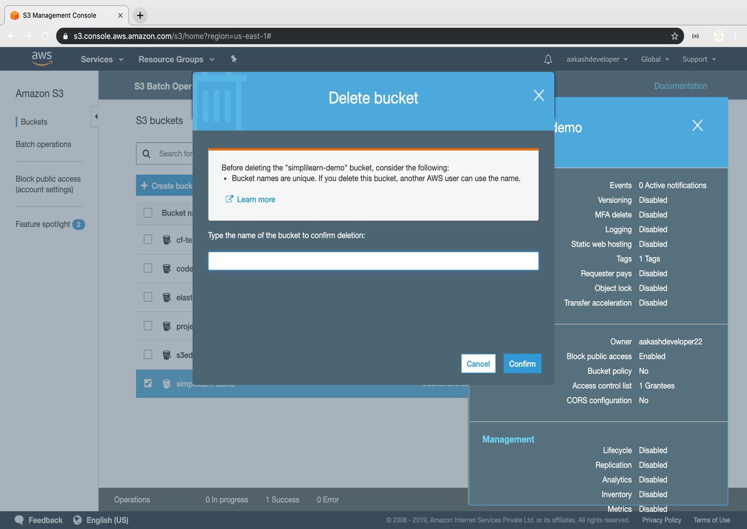

**Step 3.12.3:** Pushing the code to your GitHub repositories

* Open your command prompt and navigate to the folder where you have created your files.

**cd <folder path>**

* Initialize your repository using the following command:

**git init**

* Add all the files to your git repository using the following command:

**git add .**

* Commit the changes using the following command:

**git commit . -m “Changes have been committed.”**

* Push the files to the folder you initially created using the following command:

**git push -u origin master**